Planning Application 23/00203/P
Dirleton Village Association (DVA) response.
The DVA submitted a response to The Renaissance Club’s (TRC) planning application (ref. 23/00179/P) for change of use of woodland to form hardstanding for a media centre. Our detailed reasons for objection to this latest application by TRC are as follows:
- The proposed cottage and grounds at the eastern end of the proposed development lie wholly within Dirleton Conservation Area, and the remainder of the development lies immediately adjacent to it. To assess the extent of tree felling proposed we have used the Tree Survey & Arboricultural Impact Assessment, dated 16th September 2021, submitted in support of the planning application 19/0087/P, as an updated report has not been submitted in support of this application. It is noteworthy that the author of the report identifies that the report is only valid for 12 months.
We estimate that c.94 trees are to be felled to enable construction of the 6 cottages proposed, 16 of which lie within the conservation area. The drawing Proposed Landscaping - Area A, dated 23rd March 2023, shows that just 18 new trees are to be planted.
The decision of East Lothian Council, which was upheld on appeal to the Scottish Government, to refuse planning application 19/00692/PM at East Fortune because of the loss of mature trees, set an important precedent. As well as various other reasons, the prime reason stated by the Scottish Government was as follows:
"The development would result in the unacceptable loss of a significant number (299) of trees, to the detriment of the climate of East Lothian, and contrary to East Lothian’s Climate Change Strategy."
We appreciate that there is a wider Woodland Management Plan (WMP) for the estate, which recognises the need to replace plantation woodland with a more naturalised species diversity and distribution. However, the 15-year programme of the WMP does little to support the climate change strategy and its enforcement is still appropriate in this case.
It is really frustrating that East Lothian Council were not consistent with their considered opinion to refuse the East Fortune application when in 2021 they consented TRC’s application for 10 cabins and 6 cottages, which will result in the loss of a similar number of trees.

- Aside from the loss of woodland to recent residential development at Kiformngs Cairn (Eldbotle Wood), Pheasant Walk and Renaissance View (Broad Wood) and Duncan’s Plantation, the historical photographs below (using Google Earth and Google Streetview) show the extent of the loss of woodland to Renaissance Golf Club over recent years.
June 2006
September 2011

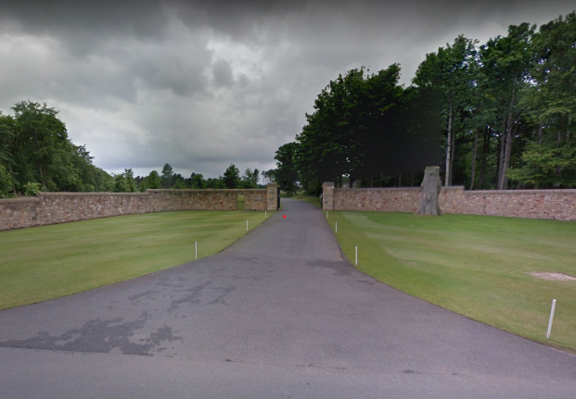
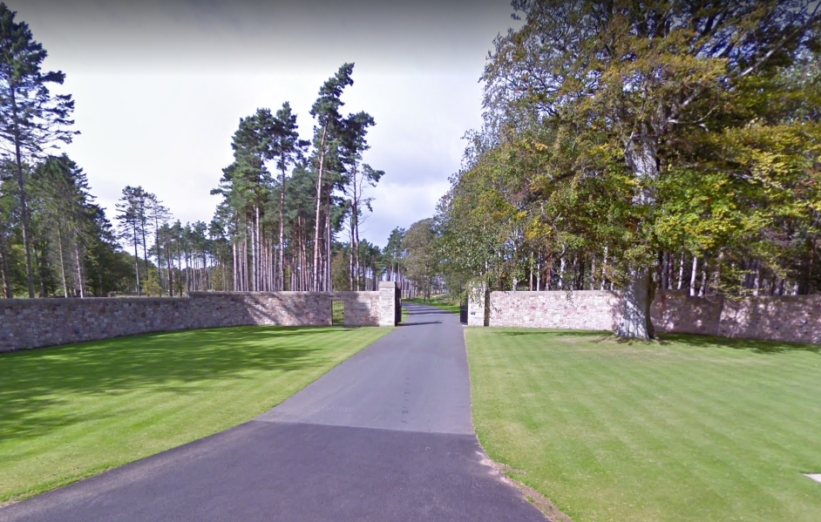

September 2011
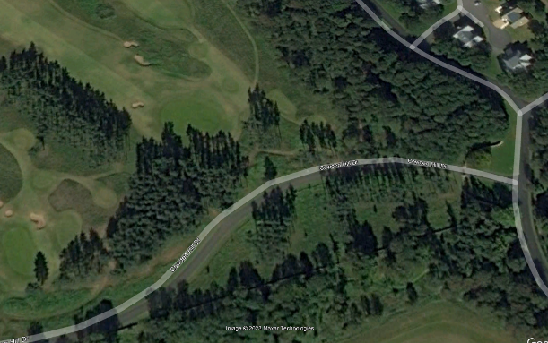
September 2018
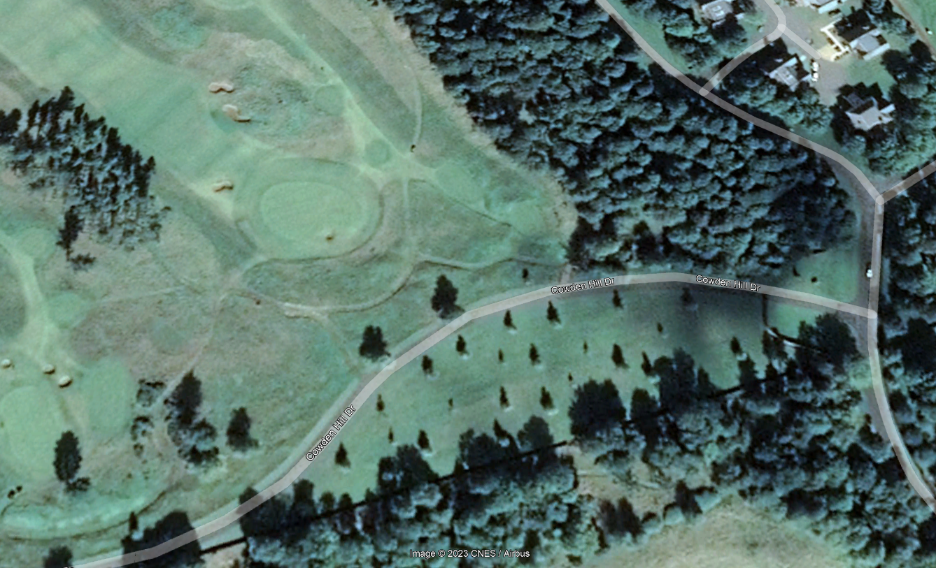

December 2006
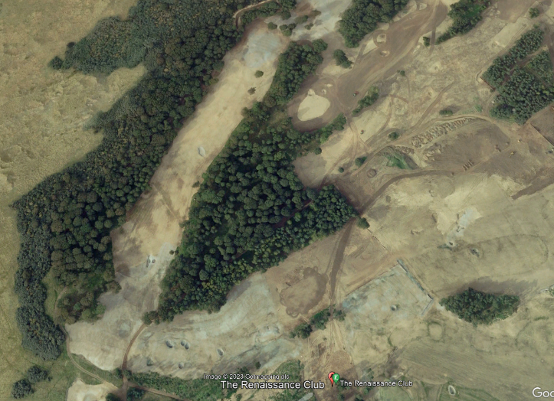
September 2011
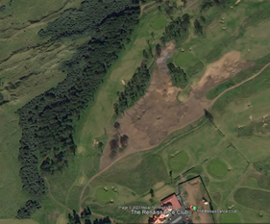
The cumulative effect of the planning applications on the remaining woodland has to be considered seriously by East Lothian Council.

- Opening up the wood to accommodate each of the proposed plots will enable trees to be wind loaded in directions they have never been exposed to and therefore prone to being blown down or damaged by high winds, posing a risk to visitors.

- The woodland copse is a remnant of Broad Wood, which is recorded as an extensive area of woodland on the earliest OS mapping 1853. The Woodland Map for Archerfield and Dirleton Mains, shows how fragmented the wood has become. The trees themselves are probably about 40 years old. There would need to be a substantial replanting schedule to even just recover the carbon capture, ecological and environmental value of the existing trees proposed for felling. Considering the felling carried out to form the golf course, this could not be undertaken locally.

- A Preliminary Ecological Assessment (PEA) has not been submitted. The ecological report submitted in support of the planning application 19/00087/P was prepared in October 2019 and not only is this now considered to be out of date, but it does not identify that the development then proposed lies adjacent to Dirleton Conservation Area, and the current application actually lies partly within it. The requirement to undertake a PEA was raised by the case officer for the 2019 application and we would expect a new PEA to be requested.

- The planning application title and description is deceiving. To refer to properties with 8 double bedrooms all with en-suite bathrooms as “cottages” is laughable.

- The proposed “cottages” are purported to be for visitors to TRC, who will presumably be playing golf. Assuming that only one of the occupants of each of the 8 bedrooms is playing golf, the size of the golf club storage/cloakroom is shown as 2.1m x c.1.8m is considered inappropriate.

- Only four parking spaces are shown for an 8-bedroom property, this is considered inappropriate.

- There are no proposals for SUDS for the development. It is highly unlikely that Scottish Water will allow surface water to be discharged into the public sewer. Soakaways may be appropriate for the likely sandy soil type; however these would need to be designed appropriately.

We make no excuse for using many of the same reasons for objection as applied to our response made earlier this month to planning application 23/00179/P.

Regards
Dirleton Village Association

