Planning Application 23/00179/P
Dirleton Village Association (DVA) response.
The decision of East Lothian Council, which was upheld on appeal to the Scottish Government, to refuse planning application 19/00692/PM at East Fortune because of the loss of mature trees, set an important precedent. As well as various other reasons, the prime reason stated by the Scottish Government was as follows:
"The development would result in the unacceptable loss of a significant number (299) of trees, to the detriment of the climate of East Lothian, and contrary to East Lothian’s Climate Change Strategy."
Although The Renaissance Club (TRC) propose to fell fewer trees in this application, the climate change strategy and its enforcement are still appropriate in this case.
Although the proposed development in question at TRC lies just outside Dirleton Conservation Area, the DVA objects to the felling of a woodland area to construct a media compound because it would cause the loss of yet more mature trees on this site. Our detailed reasons for this objection are as follows:
- Aside from the loss of woodland to recent residential development at Kiformngs Cairn (Eldbotle Wood), Pheasant Walk and Renaissance View (Broad Wood) and Duncan’s Plantation, the historical photographs below (using Google Earth and Google Streetview) show the extent of the loss of woodland to Renaissance Golf Club over recent years.
June 2006
September 2011

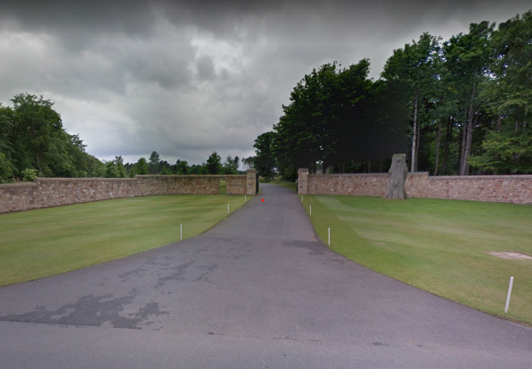
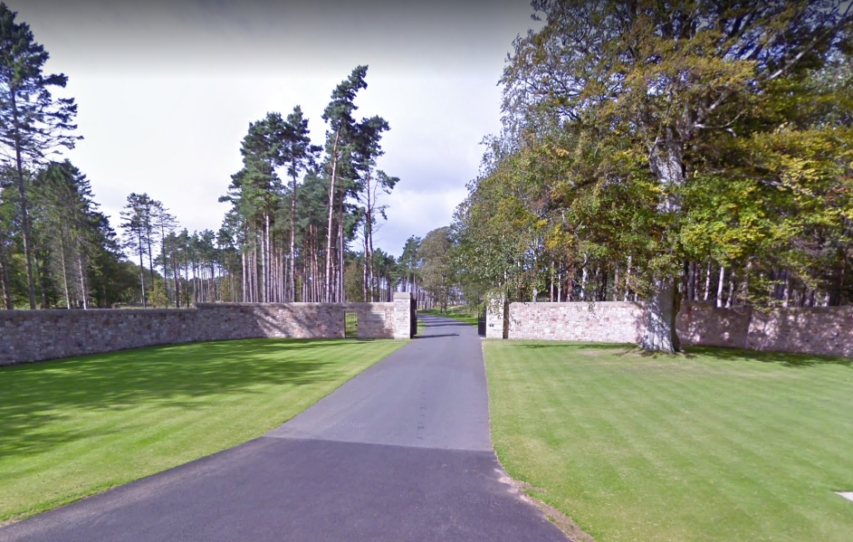

September 2011
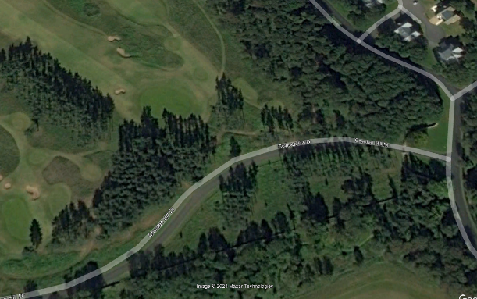
September 2018
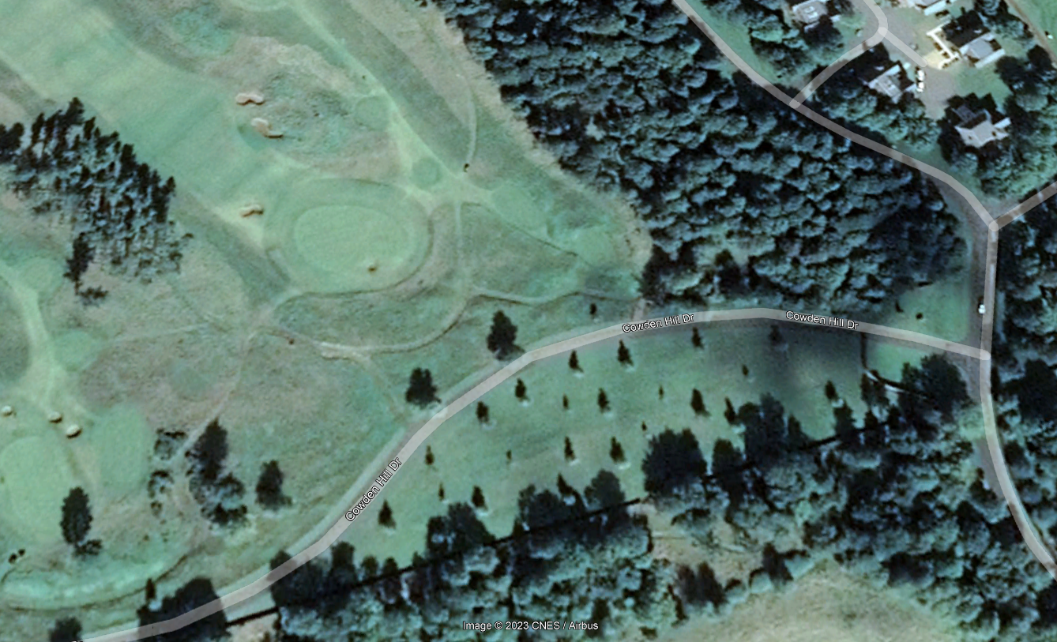

December 2006
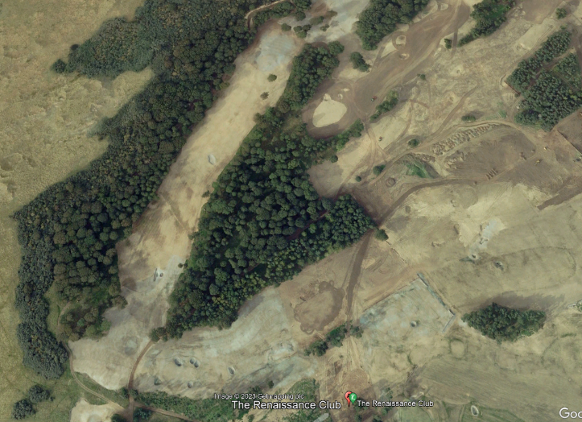
September 2011
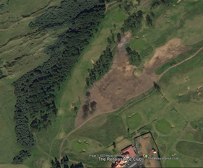

- The Arboricultural Assessment and Preliminary Ecological Assessment (PEA) must be considered biased, as they are written by the agent for the development. Mr Rechberger’s arbouricultural credentials are not questioned, but we have been unable to identify what training or experience he has to undertake a PEA. The arbouricultural survey identifies mechanical damage to numerous trees, presumably due to the mismanagement of TRC contractors in the past. This is now being used as a reason to fell the trees.

- Opening up the wood will enable trees to be wind loaded in directions they have never been exposed to and therefore prone to being blown down or damaged by high winds, posing a risk to golfers and the proposed media centre. The arbouricultural assessment makes reference to surveying the remaining trees annually, presumably to see whether the trees have been harmed irreparably by the development and further felling is required.

- The woodland copse is a remnant of Broad Wood, which is recorded as an extensive area of woodland on the earliest OS mapping 1853. The Woodland Map for Archerfield and Dirleton Mains, included within the Arbouricultural Assessment, shows how fragmented the wood has become. The trees themselves are probably about 40 years old. There would need to be a substantial replanting schedule to even just recover the carbon capture, ecological and environmental value of the existing trees proposed for felling. Considering the felling carried out to form the golf course, this could not be undertaken locally.

- The Media Centre is to support for the Open Golf Championship, which is only to be held at TRC until 2026. What happens then – redevelopment?
At what point do East Lothian Council say enough is enough?

Regards
Dirleton Village Association

